Safin Salih

12/2/2017

Senior Seminar

Dr. Yi Jiang

**Cigarettes & E-Cigarettes Among College Aged Students: A Useful Application of Logistic Regression**

Safin Salih , Corey Cooper

Georgia State University

**Abstract**

We introduce a model that could best predict the probability of a given Georgia State University student who smokes tobacco, the willingness to transition from cigarette to electronic cigarette; based on the 84 observation we surveyed in-person. We used SAS tool to help us analyze and create a best fit model. In doing so, we conclude the highest statistical significance predictor in the model is if they answered “yes” or” no” to the survey question, “Have you tried electronic cigarette?”.

**Introduction**

Walking from class to class at Georgia State University campus my research partner Corey Cooper and I noticed a specific location in which students smoked quite frequently. Some smoked regular cigarette and others smoked electronic cigarette (or e-cig for short); So curiously we wanted to know the relationship between the two. The location which students sat, socialize and smoked would become the main area in which we surveyed and gather our data sample from. Going into this research we had no specific question that we want answered except some promising relationship between e-cig users and cig users. We then began to focus on the transition from cig to e-cig for a given smoker, because this help forecast future of GSU students whom smoke tobacco. First, we’ll talk about the history of e-cig and how it’s growing, then talk about how we gather our data and the possible biases. Afterwards we’ll look at the model that SAS provided and deduce information from that model that is helpful in predicting the transition from regular cigarette to electronic cigarette.

**Background**

Since the advent of electronic cigarette back in 2013, there has been a growing interest as well as research done on e-cig both financially and health wise. The earliest known patent and founder Herbert A. Gilbert in 1965[1], who was the first to make smokeless non-tobacco cigarette, have had great influence on Chinese Pharmacist and inventor Hon Lik[2] who founded e-cig we know today. With the unforeseeable market of E-cig prior to 2013, the e-cig sales in the United States grew rapidly and some claim that profit could even surpass combustible cig by 2020[3]. Whether e-cig is healthier or not, this spike in growth sales is certainly good news for those who believe that e-cig is a healthier alternative to regular cigarette.

**Experiment**

After establishing the location of interest and questions to ask students on, Corey and I began in-person survey, and gather data. First few questions were to get basic information, such as age, gender, race and sex. Afterwards, questions focused more on tobacco cigarettes, what Age they began smoking, what prompt them to smoke in the first place and on average, how much in quantity of cig smoked per day. And the last three questions revolved around e-cig. Have you tried e-cig? You see yourself transitioning to e-cig completely in the future and do you believe e-cig healthier alternative? Since our sample size is n=84 and rather small, we had to minimize some of the categorical variable options to prevent outliers occurring. For instance, gender was reduced to, either Non-LGBTQ(heterosexual) or LGBTQ. The initial cause of smoking question had only three options, influence by peers, personal curiosity or alternative to some other substance (usually marijuana).

In research, the process of sampling from a population can have some bias, and ours is no exception. While may be difficult to list all, here are some possible biases that might have occurred during the in-person survey. The environment in which the survey took place could have affected some response to be more favorable. This could lead students responding to the survey question to which they feel is socially desirable or acceptable since some were surrounded by their peers. Also, the wording of a question and/or how it’s being said can also affect the response from the student.

We gathered our data, next we enter our data onto a spreadsheet via Excel, then use the software SAS to read off Excel. SAS is an advance analytic tool that played a key role in helping us analyze and come up with the best fit model. Now, that we have our dataset and our SAS tool, let’s look at some frequency table to get a good sense of our sample population. As seen below, %83.33 have tried e-cig in the past, %76.9 believe it’s healthier and only %53 willing to transition to e-cig.

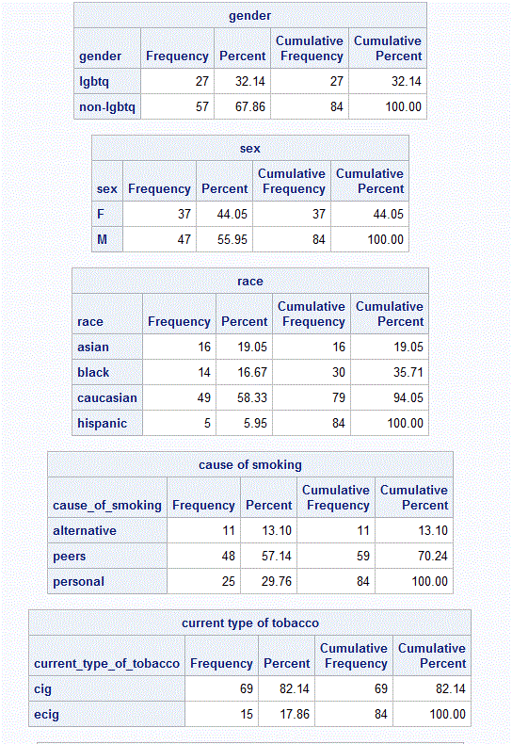 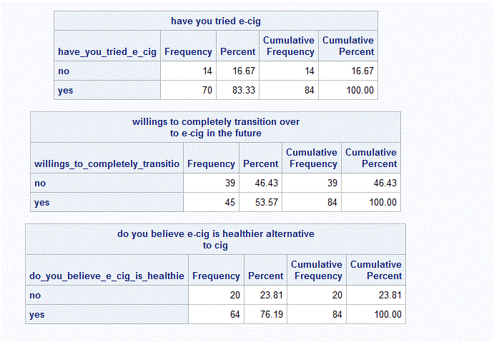

The variable of interest is the willingness to transition from cig to e-cig, and since this question on the survey prompts a yes or no response, a binary response. We are unable to use linear regression; hence binary (or binomial) logistic regression is a viable option. In binary logistic regression, independent variable can be either continuous or categorical and while the dependent variable remains dichotomous. The logistic formula follows:

Pr(Y=1) = $\frac{1}{1+e^{-(B_{0}+B_{1}X_{1}….B_{k}X_{k})}}$, and logit form $\log_{e}{(\frac{pr\left(y=1\right)}{1-pr\left(y=1\right)})}=B_{0}+B_{1}X_{1}….B_{k}X_{k}$

Where Pr(Y=1) means the probability of success, in our case, the probability of saying yes to the question “willingness to transition over to e-cig”. While our predictor variables $X_{k}$ have a corresponding coefficient $B_{k}$. The coefficients $B_{k}$ in our logistic regression model tells us valuable information about the relationship between the predictor to the dichotomous dependent variable. These coefficients are often used to estimate a parameter called odds ratio.

**Model**

Now before coming up with a model, one must consider of weighting how many predictors they want to include in their model. If we were to choose one predictor with statistically high significance, meaning at alpha=0.05, the corresponding p-value is less than alpha, this resulted in a poor fit model. Adding more predictor variable into our model will increase our c-statistics, all while trying to keep our AIC low and maintaining the overall significance of the whole model. The best fit model we found that best predict the probability of transitioning from cig to e-cig: 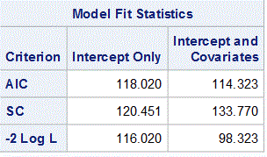 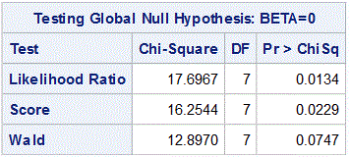

$\log_{e}{[odds(y=\text{'yes')]= -1.9}792-1.1751x_{1}-.6768x_{2}+.0023x_{3}+.0186x_{4}-.3621x_{5}+.1195x_{6}+.0557x_{7}}$. In probability form, Pr(y=’yes’) = $\frac{1}{1+e^{- (\text{-1.}9792-1.1751x_{1}-.6768x_{2}+.0023x_{3}+.0186x_{4}-.3621x_{5}+.1195x_{6}+.0557x_{7})}}$

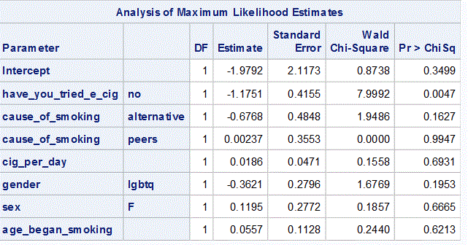 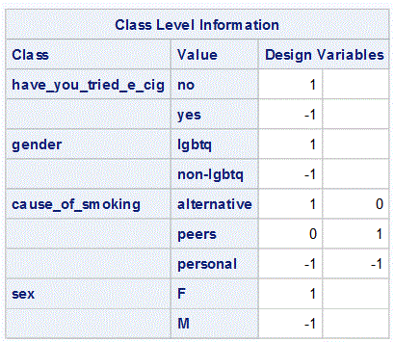

Where $x_{1},x_{2}, x_{3}, x_{4}, x_{5},x_{6},x_{7}$ are in the respected order. ($x_{1}=have you tried ecig, x_{2}=cause of smoking…$)For example, if the subject said cause of smoking was for personal curiosity, both $x_{2} and x_{3} get-1 in the given model above.$ As seen from the table of “Analysis of Maximum Likelihood Estimates”, the predictor variable “Have_you_tried_e_cig” has a very highest Wald Chi-Square amongst all and a low corresponding p-value that is less than alpha = 0.05 . Meaning this predictor plays an important role in deciding whether the smoker is willing to transition to e-cig or not.

**Conclusion**

Whether you are for electronic cigarette or against it, the numbers in sales reveal that it is here to stay and will be relevant in upcoming years. It’s no surprise more research is being conducted in this field. We gathered some useful information from our model, such that if the person we surveyed said they have tried electronic cigarette in the past, they are more likely to see themselves completely transition over to electronic cigarette. This news might incentives firms who are in the e-cig market and give out free electronic cigarette as free trials and may benefit in the long run.

==========================================================================

Reference

1. Salon: in-depth news, politics, business, technology & culture. *America’s vaping revolution: How suspicious should we really be of the e-cigarette craze? - Salon.com.*Retrieved from http://www.salon.com/2014/12/07/americas_vaping_revolution_how_suspicious_should_we_really_be_of_the_e_cigarette_craze/

2. ( Featured Articles From The LA Times. *A high-tech approach to getting a nicotine fix - latimes.*Retrieved from http://articles.latimes.com/2009/apr/25/world/fg-china-cigarettes25

3. Harvard T.H. Chan School of Public Health | Powerful ideas for a healthier world. *The E- Cig Quandary | Harvard Public Health Magazine | Harvard T.H. Chan School of Public Health.*Retrieved from http://www.hsph.harvard.edu/magazine/magazine_article/the-e-cig-quandary/